Game pitch:
Do you like real-time strategy games? Well, how about a unique real-time strategy game lost to time? Send your units out from your castle and down various paths to counter the enemy units and capture beneficial checkpoints. Out play your opponent until your units reach the enemy fort and burn it to the ground. Beat levels to gain materials to unlock new units and upgrade your existing ones, allowing you to get even stronger and win. Play through levels with unique path layouts and challenges.

Game Synopsis:
Game consists of a sequence of levels. In each level, at one end of the field is the player’s castle and at the other is the enemy’s. The two castles are connected by branching paths, with a variety of different checkpoints along the path that can be captured for different benefits. The player build resources over time, which they use to send units out along the path. Enemy units fight when they reach each other, pausing in place before continuing when the fight ends. When units reach the enemy castle and enter it they damage it, and once enough enter the castle is destroyed and the player wins. Outside of levels the player can upgrade their units and unlock new ones to use in future levels.

Objective:
Send your units along the path to reach the enemy castle, to get enough units into the enemy castle to destroy it.

Description of mechanics:
Player spawns several different types of units, sending them down the path and directing them on which branch to go. Enemy units along the path fight and can capture checkpoints to protect for benefits. By reaching and entering the enemy castle soldiers damage it, until eventually it is destroyed.

Example of Mockup:
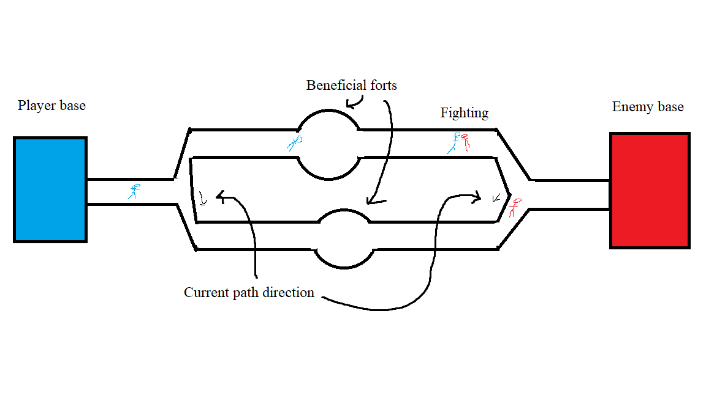
Levels will be shaped similarly to this, with potentially more branches and checkpoints, adding unique checkpoints for special effects and benefits.

